JS Applications Retake Exam – Local Orphanages
In this day and age, thousands of children have to live in a cold, lonely world, without the support of their parents. Left in an orphanage, they are forced to live without the presence of many things that bring them joy and happiness. Your task is to create an app and give an opportunity to volunteers to send resources which will support orphanages around the country.
You are assigned to implement a Single-Page Web application (SPA) using JavaScript. The application should dynamically display content, based on the user’s interactions, and support user profiles and CRUD operations, using a REST service.
Only the last submission will be evaluated!

Overview
Implement a front-end app (SPA) for viewing and managing the needs of local orphanages. The application allows visitors to browse through the posts catalog. Users may register with an email and password, which allows them to make a post about the resources needed or donate to different orphanages. Post authors can also edit and delete their own posts at any time.
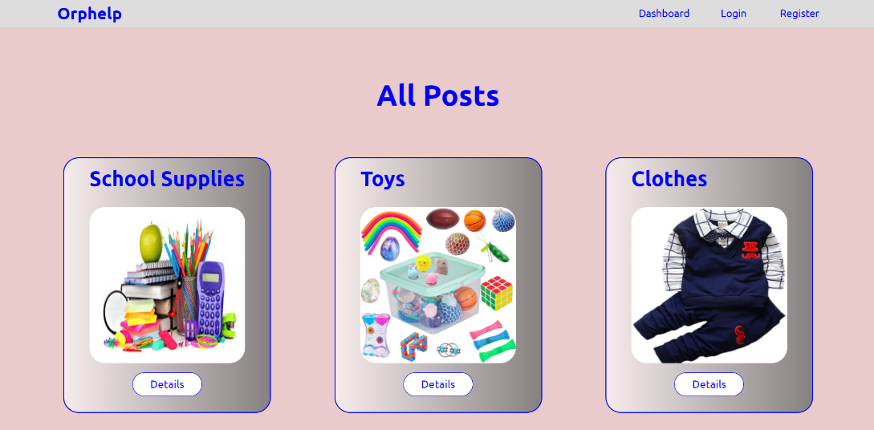

Technical Details
You are provided with the following resources:
- Project scaffold: A package.json file, containing a list of common dependencies. You may change the included libraries to your preference. The sections devDependencies and scripts of the file are used by the automated testing suite, altering them may result in incorrect test operation.
To initialize the project, execute the command npm install via the command-line terminal.
- HTML and CSS files: All views (pages) of the application, including sample user-generated content, are included in the file index.html, which links to CSS and other static files. Each view is in a separate section of the file, which can be identified by a unique class name or id attribute. Your application may use any preferred method (such as a templating library or manual visibility settings) to display only the selected view and to navigate between views upon user interaction.
- Local REST service: A special server, which contains sample data and supports user registration and CRUD operations via REST requests is included with the project. Each section of this document (where applicable) includes details about the necessary REST endpoints, to which requests must be sent, and the shape of the expected request body.
For more information on how to use the included server, see Appendix A: Using the Local REST Service at the end of this document.
- Automated tests: A complete test suite is included, which can be used to test the correctness of your solution. Your work will be assessed, based on these tests.
For more information on how to run the tests, see Appendix B: Running the Test Suite at the end of this document.

Do not use CDN for loading the dependencies because it can affect the tests in a negative way!
Note: When creating HTML Elements and displaying them on the page, adhere as closely as possible to the provided HTML samples. Changing the structure of the document may prevent the tests from running correctly, which will adversely affect your assessment grade. You may add attributes (such as class and dataset) to any HTML Element, as well as change the "href" attributes on links and add/change the method and action attributes of HTML Forms, to facilitate the correct operation of a routing library or another method of abstraction. You may also add hidden elements to help you implement certain parts of the application requirements.

Application Requirements

Navigation Bar (5 pts)
Implement a NavBar for the app: navigation links should correctly change the current screen (view).
Navigation links should correctly change the current page (view). Guests (non-authenticated visitors) can see the links to the Dashboard, as well as the links to the Login and Register pages. The logged-in user navbar should contain the links to the Dashboard page, My Posts page, the Create Post page, and a link for the Logout action.
User navigation example:

Guest navigation example:

Login User (5 pts)
The included REST service comes with the following premade user accounts, which you may use for development:
{ "email": "peter@abv.bg", "password": "123456" }
{ "email": "john@abv.bg", "password": "123456" }
The Login page contains a form for existing user authentication. After the user enters an email and a password, the app should log in the user in the system if there are no empty fields.
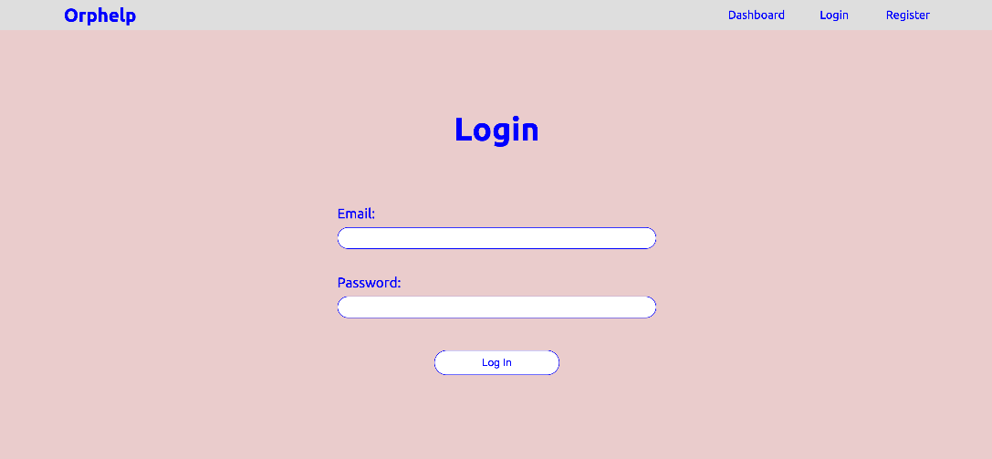
Send the following request to perform login:
Method: POST
URL: /users/login
Required headers are described in the documentation. The service expects a body with the following structure:
{
email,
password
}
Upon success, the REST service will return the newly created object with an automatically generated _id and a property accessToken, which contains the session token for the user – you need to store this information using sessionStorage or localStorage, to be able to perform authenticated requests.
If the login was successful, redirect the user to the Dashboard page. If there is an error, or the validations don’t pass, display an appropriate error message, using a system dialog (window.alert).

Register User (10 pts)
The Register page contains a form for new user registration. After the user enters an email, and password, the app should register a new user in the system.
All fields are required – if any of them is empty, display an error.
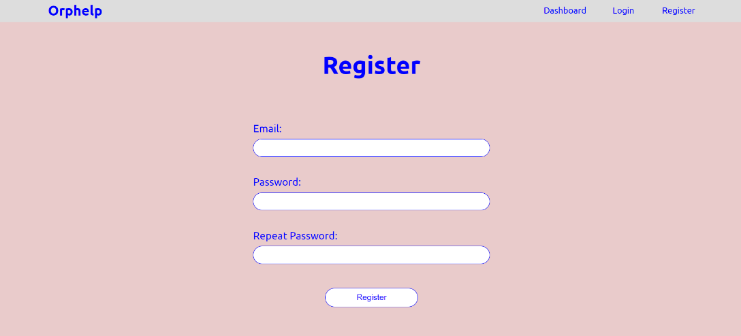
Send the following request to perform registration:
Method: POST
URL: /users/register
Required headers are described in the documentation. The service expects a body with the following shape:
{
email,
password
}
Upon success, the REST service will return the newly created object with an automatically generated _id and a property accessToken, which contains the session token for the user – you need to store this information using sessionStorage or localStorage, to be able to perform authenticated requests.
If the registration was successful, redirect the user to the Dashboard page. If there is an error or the validations don’t pass, display an appropriate error message, using a system dialog (window.alert).

Logout (5 pts)
The logout action is available to logged-in users. Send the following request to perform logout:
Method: GET
URL: /users/logout
The required headers are described in the documentation. Upon success, the REST service will return an empty response. Clear any session information you’ve stored in the browser storage.
If the logout was successful, redirect the user to the Dashboard page.

Dashboard (15 pts)
The Dashboard Page displays a list of all materials needed by all the orphanages in the system. Clicking on the [Details] button in the cards leads to the details page for the selected post. This page should be visible to both guests and logged-in users.
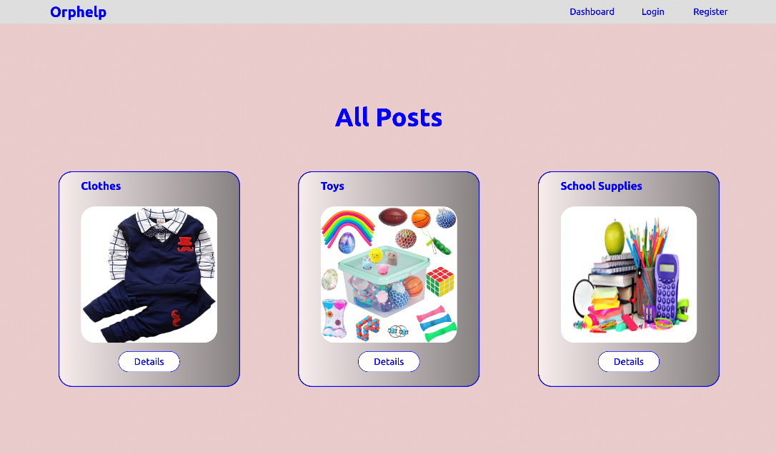
If there are no posts, the following view should be displayed:
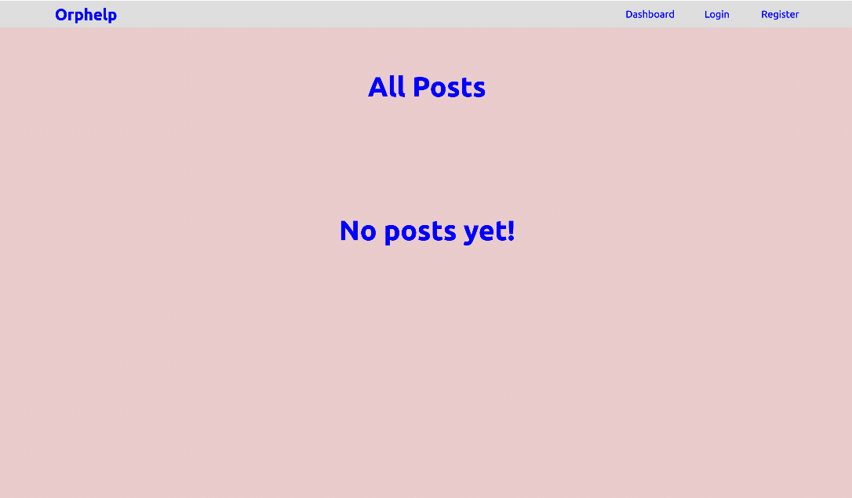
Send the following request to read the list of posts:
Method: GET
URL: /data/posts?sortBy=_createdOn%20desc
The required headers are described in the documentation. The service will return an array of posts

Create Page (15 pts)
The Create page is available to logged-in users. It contains a form for adding a new post about necessary materials or services. Check if all the fields are filled out before you send the request.
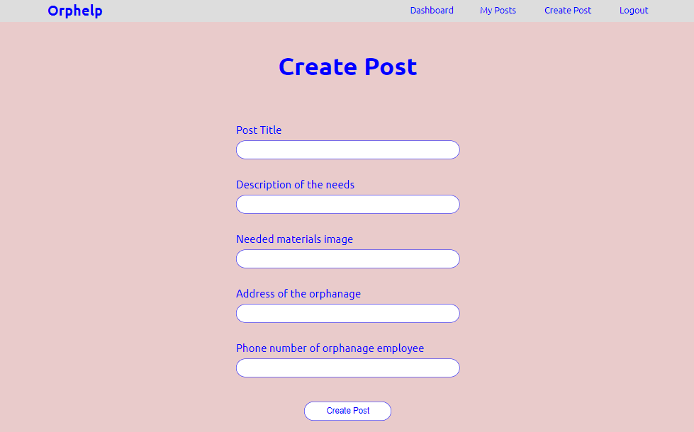
To create a post, send the following request:
Method: POST
URL: /data/posts
The required headers are described in the documentation. The user must enter:
- title - the materials needed to be donated
- description – more detailed information about the needed materials – size, quantity, etc.
- imageUrl – an image of the expected material
- address – the address where the materials need to be sent
- phone – a phone number on which the orphanage employee can be contacted
The service expects a body with the following shape:
{
title,
description,
imageUrl,
address,
phone
}
The required headers are described in the documentation. The service will return the newly created record. Upon success, redirect the user to the Dashboard page.

Details (10 pts)
All users should be able to view the details about the posts. Clicking the [Details] button on the post on the dashboard page should display the Details page. If the currently logged-in user is the author, the Edit and Delete buttons should be displayed, otherwise, they should not be visible. The view for the authors should look like this:
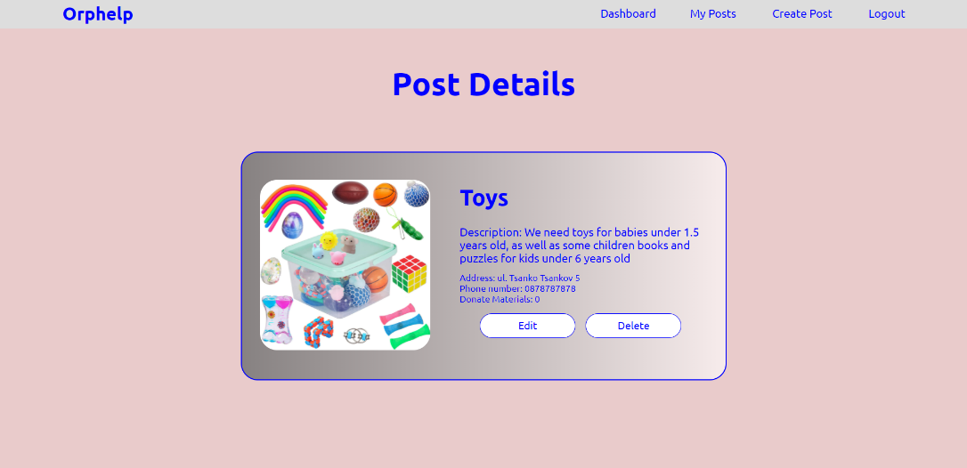
The view for the no-author should look like this:
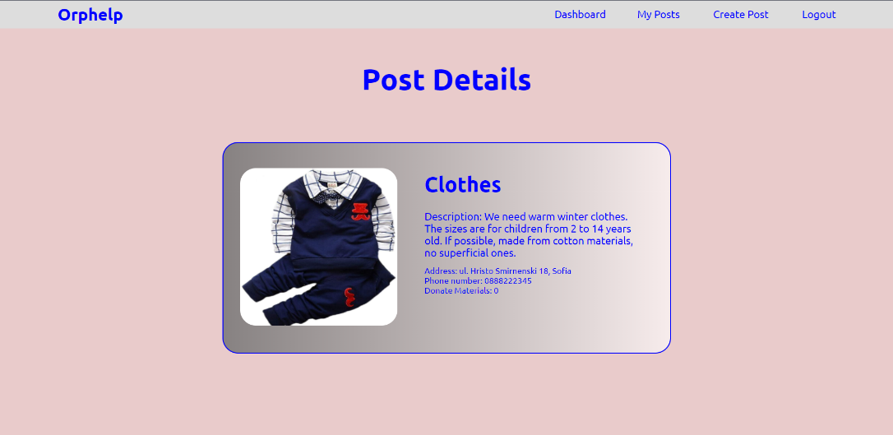
If there is no logged-in user the details page should look like this:
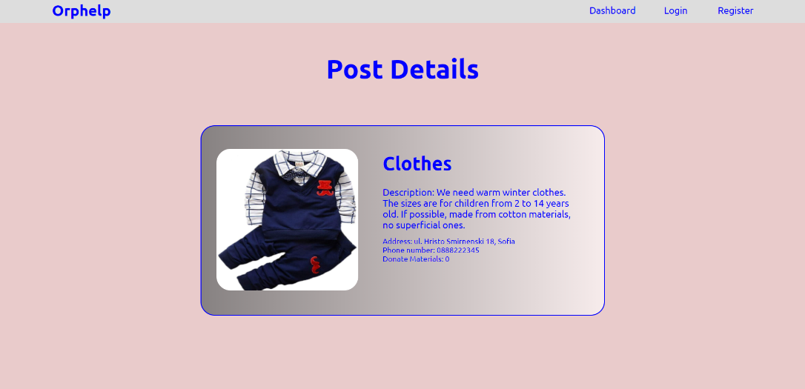
Send the following request to read a single post:
Method: GET
URL: /data/posts/:id
Where :id is the id of the desired post. The required headers are described in the documentation. The service will return a single object.

Edit Page (15 pts)
The Edit page is available to logged-in users and it allows authors to edit their own post. Clicking the [Edit] button of a particular post on the Details page should display the Edit page, with all fields filled with the data for the post. It contains a form with input fields for all relevant properties. Check if all the fields are filled before you send the request. The fields must be filled in with the previous data when the page is first loaded.
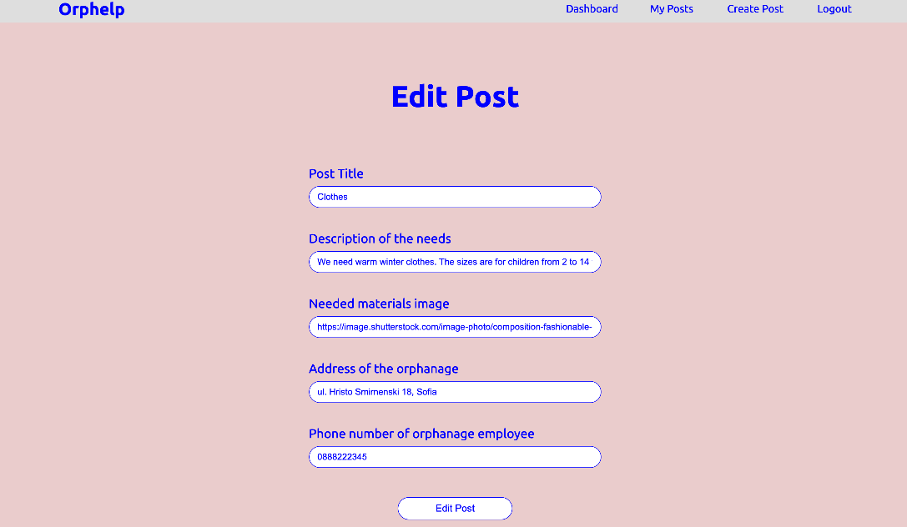
To edit a post, send the following request:
Method: PUT
URL: /data/posts/:id
Where :id is the id of the desired card.
The service expects a body with the following shape:
{
title,
description,
imageUrl,
address,
phone
}
The required headers are described in the documentation. The service will return the modified record. Note that PUT requests do not merge properties and will instead replace the entire record. Upon success, redirect the user to the Details page for the current post.

Delete Post (10 pts)
The delete action is available to logged-in users for posts they have created. When the author clicks on the [Delete] button on any of their posts, a confirmation dialog should be displayed, and upon confirming this dialog, the post should be deleted from the system and the user should be redirected to the Dashboard page.
To delete a post, send the following request:
Method: DELETE
URL: /data/posts/:id
Where :id is the id of the desired post. The required headers are described in the documentation. The service will return an object containing the deletion time. Upon success, redirect the user to the Dashboard page.

My Posts (10 pts)
Each logged-in user should be able to view his posts by clicking [My Posts]. All the posts added by the current user should be displayed.
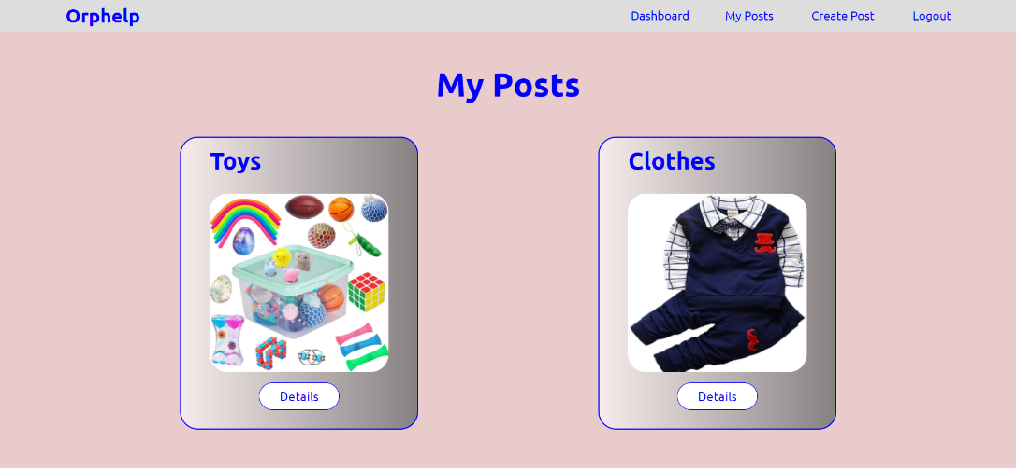
If there are no posts, the following view should be displayed:
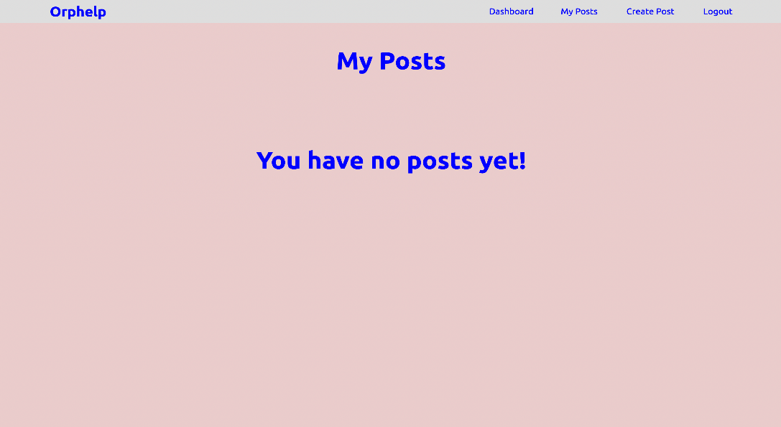
Send the following request to read the list of ads:
Method: GET
URL: /data/posts?where=_ownerId%3D%22{userId}%22&sortBy=_createdOn%20desc
Where {userId} is the id of the currently logged-in user. The required headers are described in the documentation. The service will return an array of books.

BONUS: Donate materials (15 Pts)
Every logged-in user should be able to donate materials requested in a post. By clicking on the [Donate] button, the donation of each post increases by 1.
The view when the user has not pressed the [Donate] button should look like this:
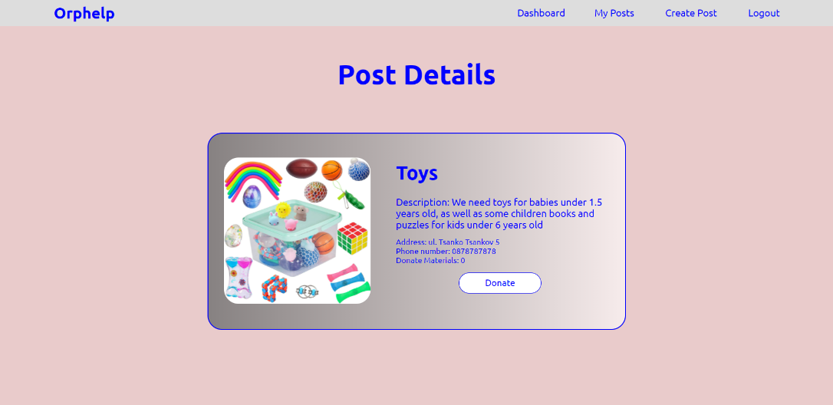
When the user has made a donation using the [Donate] button, the view should look like this:
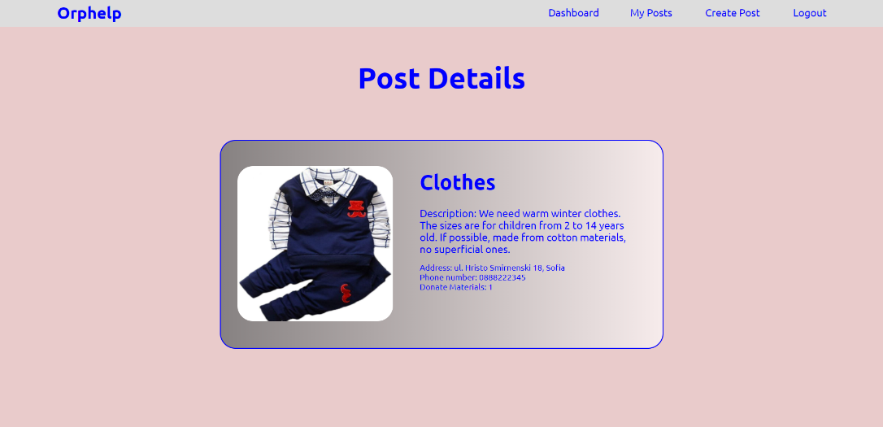
The creator should not be able to see the [Donate] button. The view should look like this:

Guests should not be able to see the [Donate] button. The view for guests should look like this:
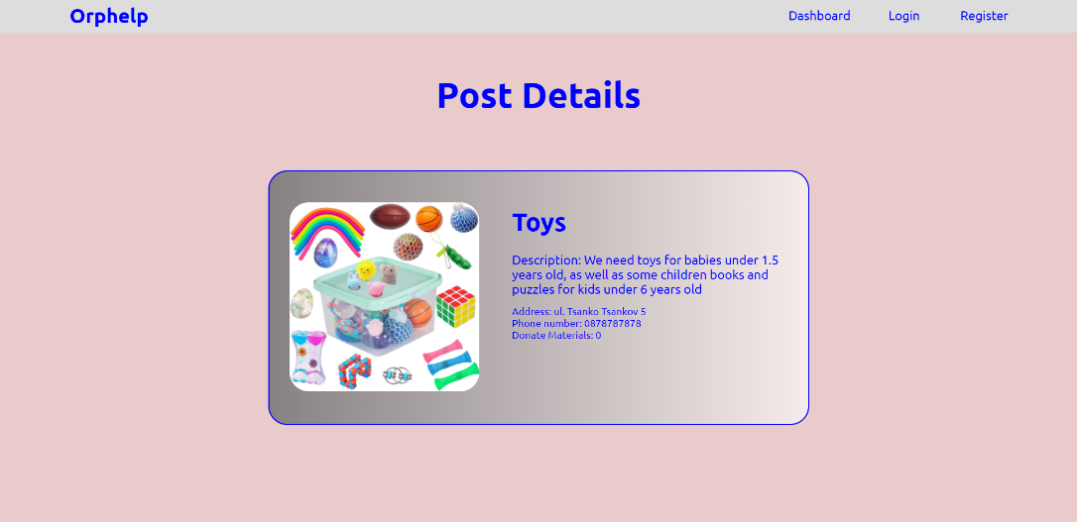
Send the following request to make a donation:
Method: POST
URL: /data/donations
The service expects a body with the following shape:
{
postId
}
The required headers are described in the documentation.
Send the following request to get the total donation count for a post:
Method: GET
URL: /data/donations?where=postId%3D%22${postId}%22&distinct=_ownerId&count
Where {postId} is the id of the desired post. Required headers are described in the documentation. The service will return the total donations count.
Send the following request to get a donation for a post from a specific user:
Method: GET
URL:/data/donations?where=postId%3D%22${postId}%22%20and%20_ownerId%3D%22${userId}%22&count
Where {postId} is the id of the desired post and {userId} is the id of the currently logged-in user.
Required headers are described in the documentation. The service will return either 0 or 1. Depending on that result the [Donation] button should be displayed or not.

Submitting Your Solution
Place in a ZIP file your project folder. Exclude the node_modules. Upload the archive to Judge.
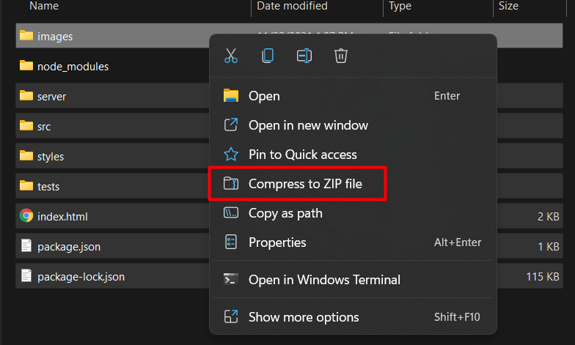
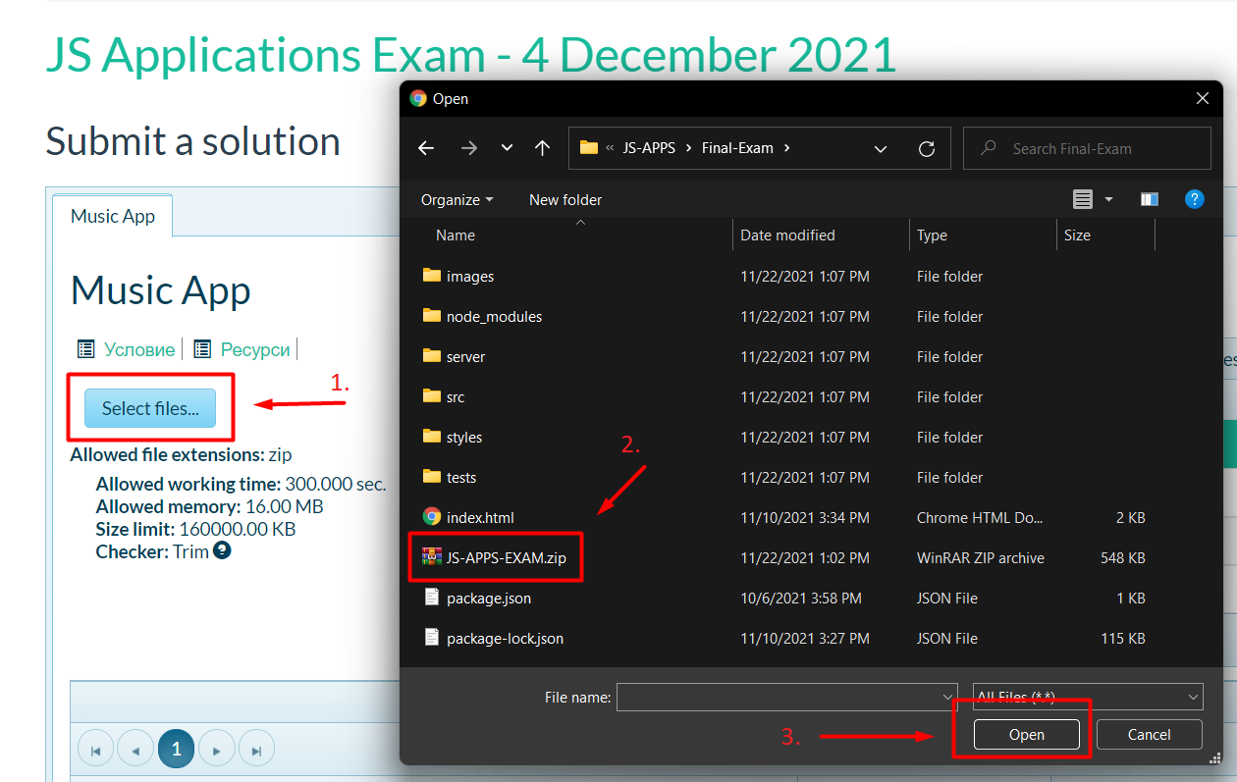
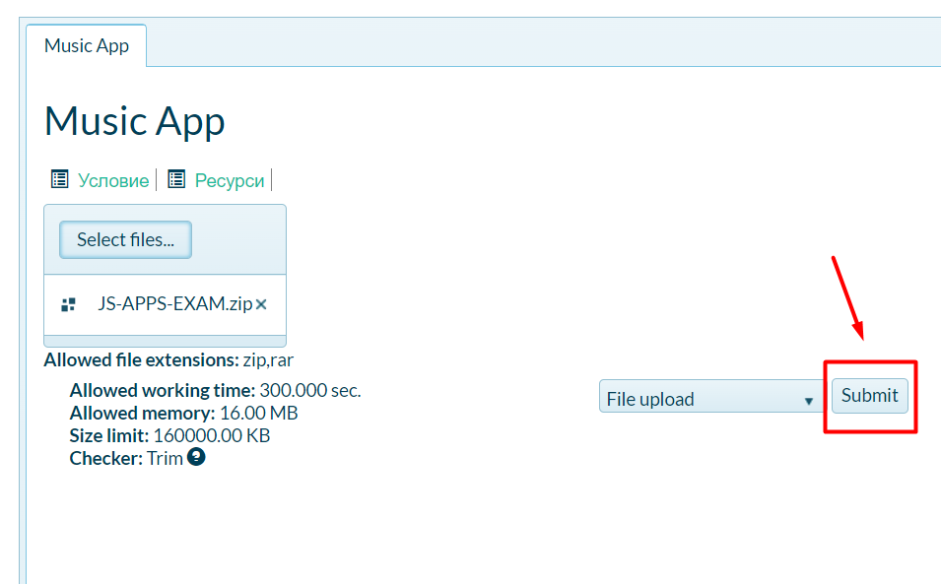
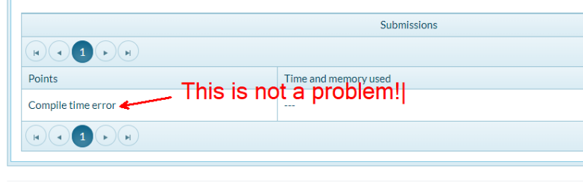

Appendix A: Using the Local REST Service

Starting the Service
The REST service will be in a folder named “server” inside the provided resources archive. It has no dependencies and can be started by opening a terminal in its directory and executing:
node server.js
If everything initialized correctly, you should see a message about the host address and port on which the service will respond to requests.

Sending Requests
To send a request, use the hostname and port, shown in the initialization log and resource address and method as described in the application requirements. If data needs to be included in the request, it must be JSON-encoded, and the appropriate Content-Type header must be added. Similarly, if the service is to return data, it will be JSON-encoded. Note that some requests do not return a body and attempting to parse them will throw an exception.
Read requests, as well as login and register requests do not require authentication. All other requests must be authenticated.

Required Headers
To send data to the server, include a Content-Type header and encode the body as a JSON-string:
Content-Type: application/json
{JSON-encoded request body as described in the application requirements}
To perform an authenticated request, include an X-Authorization header, set to the value of the session token, returned by an earlier login or register request:
X-Authorization: {session token}

Server Response
Data response:
HTTP/1.1 200 OK
Access-Control-Allow-Origin: *
Content-Type: application/json
{JSON-encoded response data}
Empty response:
HTTP/1.1 204 No Content
Access-Control-Allow-Origin: *
Error response:
HTTP/1.1 400 Request Error
Access-Control-Allow-Origin: *
Content-Type: application/json
{JSON-encoded error message}

More Information
You can find more details on the GitHub repository of the service.

Appendix B: Running the Test Suite

Project Setup
The tests require a web server to deliver the content of the application. There is a development web server included in the project scaffold, but you may use whatever server you are familiar with. Note that specialized tools like BrowserSync may interfere with the tests. To initialize the project with its dependencies, open a terminal in the folder, containing the file package.json and execute the following:
npm install
Note that if you changed the section devDependencies of the project, the tests may not initialize properly.
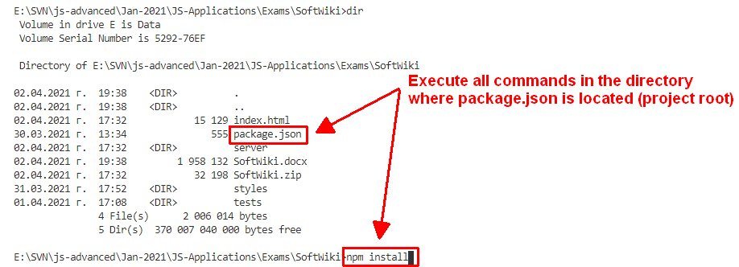

Executing the Tests
Before running the test suite, make sure a web server is operational, and the application can be found at the root of its network address. To start the included dev-server, open a terminal in the folder containing package.json and execute:
npm run start
This is a one-time operation unless you terminate the server at any point. It can be restarted with the same command as above.
To execute the tests, open a new terminal (do not close the terminal, running the web server instance) in the folder containing package.json and execute:
npm run test
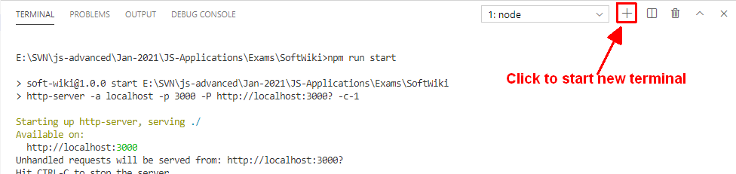
Test results will be displayed in the terminal, along with detailed information about encountered problems. You can perform this operation as many times as it is necessary by re-running the above command.

Debugging Your Solution
If a test fails, you can view detailed information about the requirements that were not met by your application. Open the file e2e.test.js in the folder tests and navigate to the desired section as described below.
This first step will not be necessary if you are using the included web server. Make sure the application host is set correctly:
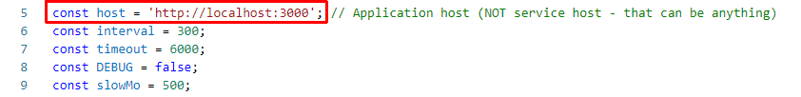
The value for the host must be the address where your application is being served. Make sure that entering this address in a regular internet browser shows your application.
To make just a single test run, instead of the full suite (useful when debugging a single failing test), find the test and append .only after the it reference:
On slower machines, some of the tests may require more time to complete. You can instruct the tests to run more slowly by slightly increasing the values for interval and timeout:
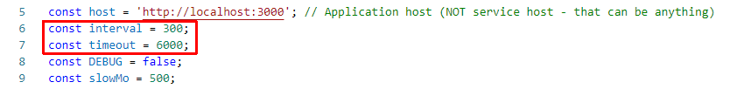
Note that interval values greater than 500 and timeout values greater than 10000 are not recommended.
If this doesn’t make the test pass, set the value of DEBUG to true and run the tests again – this will launch a browser instance and allow you to see what is being tested, what the test checks, and where it fails (or hangs):
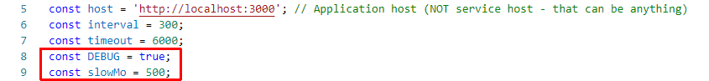
If the actions are happening too fast, you can increase the value of slow-mo. If the browser hangs, you can just close it and abort any remaining tests by focusing on the terminal window and pressing [Ctrl+C] followed by the letter "y" and [Enter].
The final thing to look for is the exact row where the test fails:
